A comparison of LandXML, ISO 19152:2012 LADM, and the draft LandInfra conceptual model
Erik Stubkjær, Aalborg University, Denmark
est@land.aau.dk

Geospatial-BIM-Indoor Workshop, Boulder, Colorado, 2 June 2015
Draft version of 20150526: Do not copy, cite, or distribute without permission of the author. Deleted 2020-04-04 est

1. Introduction
The purpose of this note is to motivate the scope, structure, and content of the Survey and the Land Parcels parts of the LandInfra Conceptual Model. More specifically, it provides an analytical basis for deciding whether the LandInfra Concept Model (LandInfra for short) should include a genuine subset of the content of ISO 19152:2012 Land Administration Domain Model (LADM), perhaps with a deviating terminology, or whether only some conceptual similarity should be aspired to.
Following a methodology section, the remainder of this note is structured as follows:
- Summary of purpose, history, content overview and selected elements of: LandXML, LADM, and the draft LandInfra conceptual model (14-116_OGC_Draft_LandInfra_Conceptual_Model.docx)
- Comparisons in tabular form
- Conclusion: Motivated suggestions for LandInfra development

2. A methodology for comparing standards
A comparison of standards by the Task Force under the Standards Subcommittee (IEEE Transformers Committee, 2011) addressed the following items:
- General
  - Scope, included and excluded
  - Word usage
  - Definitions
- For each domain specific subject issue:
  - Description
  - Standards id
  - Requirements
A Comparison of Hazard Communication Requirements, provided by the US Occupational Safety and Health Administration, confirmed the above items, and moreover included Purpose, Classifications, and Information and Training, respectively.
Standards provide specifications of a domain. Specification of domains is provided also by 1) controlled vocabularies, 2) thesauri, and 3) ontologies, as explored by the OGC GeoSemantics Domain Working Group. These three knowledge organisation systems are listed here according to increased degree of formalization. A thesaurus was developed on the basis of ISO 19152:2012 Land Administration Domain Model (LADM), namely the Cadastre and Land Administration Thesaurus (CaLAThe). Moreover, within the EU e-Government Core Vocabularies project a Core Immovable Property Vocabulary has been specified with the Linked Data approach by means of the Resource Description Framework Schema (RDF Schema) by simplifying and capturing minimal characteristics of complex domain standards and data specifications, e.g. ISO 19152:2012 Land Administration Domain Model, OGC 12-019:2012 CityGML, and related INSPIRE data specifications, cf. joinup; Çağdaş V., Stubkjær E., 2015; and Çağdaş V., Stubkjær E., accepted for publication. A SKOS vocabulary for Linked Land Administration: Cadastre and Land Administration Thesaurus. Land Use Policy. Structure and elements of CaLAThe and the Core Immovable Property Vocabulary (CIPV) are referred to in the comparisons.

3. Summary of context, purpose, and history

LandXML
LandXML is "a specialized XML data file format containing civil engineering and survey measurement data commonly used in the Land Development and Transportation Industries". It was developed by an open community of volunteer organizations and individuals over almost a decade. In New Zealand it became mandatory to lodge cadastral survey information using LandXML in 2007, and the schema version v1.2 was issued in August 2008 and published on the LandXML.org website. As of 2009, according to the website, the LandXML community consisted of over 650 organizations with 750 members in over 40 countries, and there were some 70 registered software products that supported LandXML (cic.vtt.fi; Cumerford, 2010; Cumerfortppt). A working draft LandXML 2.0 schema war published June 2014 (LandXML.org)
The OGC in 2004 ran a LandGML Interoperability Experiment to test methods and tools for converting between LandXML and LandGML. The US Army Corps of Engineers, Engineer Research and Development Center (ERDC), Autodesk and Galdos Systems initiated the Interoperability Experiment. The goal was to bridge the gap between Civil Engineering data and geospatial data using LandXML and GML interoperability tools. The Interoperability Experiment successfully produced two automated transformation tools to ease application development and direct end user use (Hecht, 2004). Following the establishment of Land Development DWG and SWG in 2012, the existing LandXML 1.2 schema was divided up into 17 packages, based on the LandXML element choice compositor (13-nnn_As-Is_LandXML...20130819 pxs.doc). The resultant packages, with Parcels and Survey emphasized, are:
- LandXML
- Units
- CoordinateSystem
- CoordinateGeometry
- Project
- Application
- Alignments
- Superelevation
- CrossSections
- Profile
- CgPoints
- Amendment
- GradeModel
- Monuments
- Parcels
- PlanFeatures
- PipeNetworks
- Roadways
- Surfaces
- Survey
- FeatureDictionary

Parcels
The Parcels package is summarized below. The elements which are going to be compared with other formalized vocabularies/ standards are rendered below the figure (in two columns). The same applies to the Survey package.
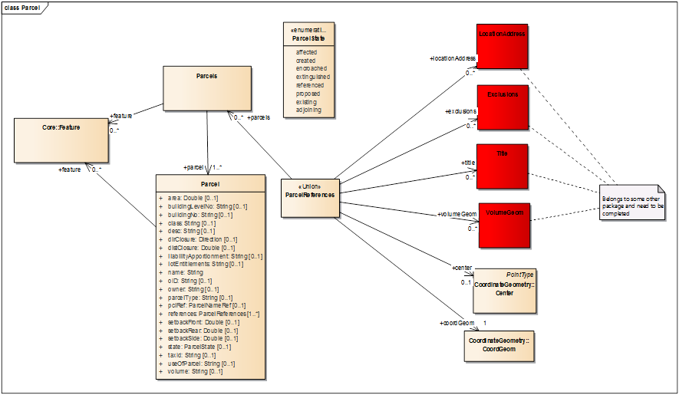
Elements, selected for comparison:
Parcels  Parcel  CoordinateGeometry::Center  CoordinateGeometry::CoordGeom  Parcel+area  Parcel+buildingLevelNo  Parcel+buildingNo  Parcel+liabilityApportionment  Parcel+lotEntitlements | Parcel+name  Parcel+owner  Parcel+parcelType  Parcel+references (LocationAddress; Title)  Parcel+setbackF..R..S  Parcel+state  Parcel+taxid  Parcel+useOfParcel  Parcel+volume

Survey
From the Survey package, only those classes which refer to target features and documentation are listed. Thus survey technology (Equipment, Setup, Observations, CgPoints, and ControlChecks) is ignored here.
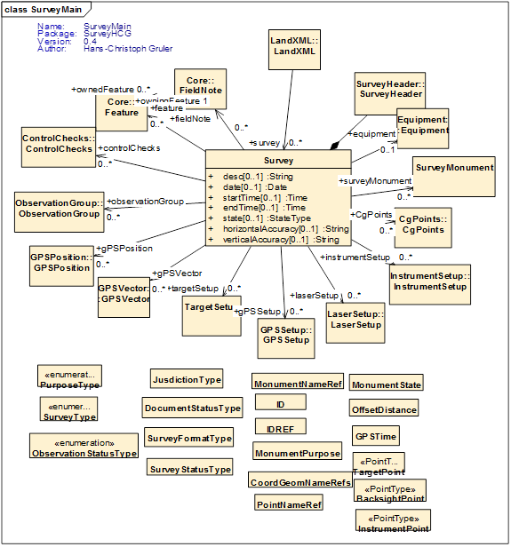

Core::Feature  Core::FieldNote | SurveyHeader  SurveyMonument

ISO 19152:2012 Land Administration Domain Model (LADM)
The idea for the introduction of a domain model for cadastre and land administration was launched at a FIG Congress in Washington (Oosterom, van, Lemmen, 2002a). During this meeting also an FIG guide on standardization (FIG, 2002) was presented and it was decided to continue standardization work. Within FIG, the standardization issue in relation to cadastre and land management was managed by the Working Group 7.3 of Commission 7, 'Cadastre and Land Management' (Lemmen, Oosterom, 2003). ISO TC 211 appeared to be interested in co-operation with FIG, and in the beginning of 2008, FIG submitted a proposal to develop an International Standard for the Land Administration (LA) domain to the ISO/TC 211 on Geographic Information of the International Organization for Standardization (ISO/TC211, 2008a). The proposal received a positive vote from the TC 211 member countries in May 2008, and within TC 211 a project team composed of 21 delegates from 17 countries framed discussion of issues and comments. A significant contribution to the development of the standard was provided by the research communities of the Faculty of Geo-Information Science and Earth Observation of the University of Twente (ITC) and Delft University of Technology, the Netherlands. It was accepted by ISO as International Standard by November 2012 (Lemmen, Oosterom, 2013).
Land administration is described by the LADM standard as 'the process of determining, recording and disseminating information about the relationship between people and land. If ownership is understood as the mechanism through which rights to land are held, we can also speak about land tenure.' (The following draws heavily on quotes from the introductory sections of the standard).
Land administration systems vary across countries or jurisdictions. However, where existing, they are all based on the relationships between people and land, linked by (ownership or use) rights, and drawing on developments in information and communication technology. The two main functions of every land administration (including cadastre and/or land registry) are
- keeping the contents of these relationships up-to-date (based on regulations and related transactions); and
- providing information from the (national) registers.
The standard covers basic information-related components of land administration (including those over water and land, and elements above and below the surface of the earth). The focus of the standard is on that part of land administration that is interested in rights, responsibilities and restrictions affecting land (or water), and the geometrical (geospatial) components thereof. It is based on the conceptual framework of ‘Cadastre 2014’ of the International Federation of Surveyors (FIG), while the geospatial aspects follow the ISO/TC 211 conceptual model.
The conceptual schema of LADM is structured into four packages with names and relations as follows:
- Party Package: parties (people and organizations);
- Administrative Package: basic administrative units, rights, responsibilities, and restrictions (ownership rights);
- Spatial Unit Package: spatial units (parcels, and the legal space of buildings and utility networks); including
- the Surveying and Representation Subpackage: spatial sources (surveying), and spatial representations (geometry and topology);
The present comparison primarily concerns the content of the latter two packages, but selected parts of the two former packages are included here as well, in order to motivate the final scope of the Infrastructure Concept Model as regards its packages on Surveying and on Land Parcels.
The following sections 5.3-5.6 are quoted from the LADM section 5 Overview of the LADM.
The standard prefixes LADM classes by LA_ to differentiate them from other classes in the ISO geographic information series of standards. Each package is commented with motivations for inclusion in LandInfra.

5.3 Party Package
The main class of the Party Package is the basic class LA_Party (with party as an instance). LA_Party has a specialization: LA_GroupParty (with group party as an instance). Between LA_Party and LA_GroupParty there is an optional association class: LA_PartyMember (with party member as an instance). See Figure 3.
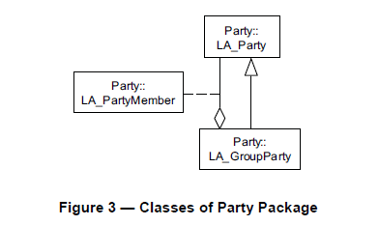
A group party, being a specialization of party, is also a party. This means that the aggregation relationship between LA_Party and LA_GroupParty in Figure 3 creates group parties with (registered) parties as constituents. Every party, being a constituent of a group party, may then be registered as a party member of class LA_PartyMember.
Further specification of LA_Party (in section 6.3.1) states that 'An instance of class LA_Party is a party. .. .. A party may be associated to zero or more [0..*] administrative sources (i.e. the author of a transfer document is defined as a party playing the role of conveyancer in a source). A party may be associated to zero or more [0..*] spatial sources (i.e. the author of a survey document is defined as a party playing the role of surveyor in a source)'.

Proposed LandInfra adoption of 5.3 Party Package
The LandInfra regards people and organizations in terms of authorities specifying needs for infrastructure projects, companies designing and constructing infrastructure, owners and other holders of right, granting right of way, and persons in charge of specific parts of the projects, e.g. land surveying. LA_Party thus needs to be represented.
LandXML provides for Parcel+owner. Similarly, LandInfra includes LandParcel+owner. As for the Land Parcel package, this should probably be supplemented with LandParcel+otherRightHolder (or +owner should be replaced by +rightHolder, where various rightHolder types could be enumerated).
The Annex of draft LandInfra A.2.3 S-3 reads: 'Goal: It should be possible to hold all the field work in an InfraGML document that could be used as a fieldbook.' Such document or field book compares to the LADM Source, which invariably includes reference to the responsible party: LA_Source+CI_responsible party, taken from ISO 19115 (LADM standard, Fig. 7 and 8, text p. 14 and 16, and Annex O, Fig. O.6). - The stated goal can hardly be reached without adding to the LandInfra a class referring to a set of measurements, a document, or source or similar. And the needed Document class needs a +responsibleParty. Cf. also [Requests] Comments regarding the OGC Draft LandInfra Conceptual Model - from Geoforum Jesper Høi Skovdal
The other classes of the package may be ignored, as LandInfra is not to account for organizational structures, unless requested by (LandXML) apportionment or (LADM) share issues.

5.4 Administrative Package
The main classes of the Administrative Package are basic classes LA_RRR and LA_BAUnit. See Figure 4.
LA_RRR is an abstract class with three specialization classes:
- LA_Right, with rights as instances. Rights are primarily in the domain of private or customary law. Ownership rights are generally based on (national) legislation, and code lists in the LADM are in support of this, see Annex J.
- LA_Restriction, with restrictions as instances. Restrictions usually "run with the land", meaning that they remain valid, even when the right to the land is transferred after the right was created (and registered). A mortgage, an instance of class LA_Mortgage, is a special restriction of the ownership right. It concerns the conveyance of a property by a debtor to a creditor, as a security for a financial loan, with the condition that the property is returned, when the loan is paid off.
- LA_Responsibility, with responsibilities as instances.
Instances of class LA_BAUnit are basic administrative units (abbreviated as baunits). Baunits are needed, among other things, to register ‘basic property units’, which consist of several spatial units, belonging to a party, under the same right (a right shall be 'homogeneous' over the whole baunit). RRR shall be unique for each baunit in order to establish a unique combination between an instance of LA_Party, an instance of a subclass of LA_RRR, and an instance of LA_BAUnit.
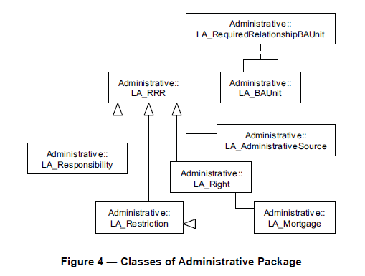
In principle, all rights, restrictions and responsibilities are based on an administrative source, as instances from class LA_AdministrativeSource. Class LA_RequiredRelationshipBAUnit allows for creating instances of relationships between baunits. Relationships can be legal, temporal, or of a spatial nature.

Proposed LandInfra adoption of 5.4 Administrative Package
The naming of this LADM package may be confusing, as it addresses legal issues, yet from the point of view of information content of recorded documents. LandInfra meets this aspect in terms of providing right of way for the infrastructure project.
Probably, LandInfra can do without referring to LA_RRR and subclasses, as administrative/ legal aspects sufficiently may be referred to through enumeration of types of boundaries (legal boundary, municipal or county boundary, demarcation of utility easements, etc). However, strictly this is a legal/ administrative issue and not a spatial issue, so it seems not satisfactorily rendered in the Survey package.
The LA_BAUnit is needed in one way or another, as this refers to management units, owned by a natural or legal person (a LA_Party). The LA_BAUnit consists of zero, one or more spatial units. To establish right of way, one or more units must be wholly or partly acquired. The zero option may be ignored.
LandXML accounts for LA_BAUnit in terms of ParcelS and the related ParcelReferences, including Title and LocationAddress (= post address). In LandXML, attributes are related to the individual Parcel, e.g. in terms of +references ParcelReferences [1..*]. Whether owner/ right holder and references /post address should be related to ParcelS or to Parcel, or to both is left open here.
In the draft, the term corresponding to BAUnit is LandParcel. The selected term may be confusing as 'parcel' normally refers to a piece of land, a lot, while BAUnit refers to a cluster of one or more of such units. PropertyUnit is proposed as an alternative. This term is used by CaLAThe and CIPV.
The class LA_AdministrativeSource, closely related to LA_SpatialSource (cf. section 5.6), which documents survey measurements, could better be dubbed Document. Any infrastructure project is based on documents of various types. Thus, the two LA_..Source classes have to be included in the LandInfra, as motivated already in previous section.

5.5 Spatial Unit Package
The main class of the Spatial Unit Package is the basic class LA_SpatialUnit, with spatial units as instances. LA_Parcel is an alias for LA_SpatialUnit, see Figure 5.
Spatial units may be grouped into two forms:
- as spatial unit groups, as instances of class LA_SpatialUnitGroup. Spatial unit groups can be further grouped into larger spatial unit groups. This is realised by an aggregation relationship of LA_SpatialUnitGroup onto itself, see Figure 5. An example of a spatial unit group is a municipality. A spatial unit group may be a grouping of other spatial unit groups. In the implementations of the LADM, this is to enable the inclusion of spatial unit identifiers in hierarchical zones.
- as sub spatial units, or subparcels, that is a grouping of a spatial unit into its parts. This is realized by an aggregation relationship of LA_SpatialUnit onto itself, see Figure 5. Parts, in their turn, may be grouped into subparts (sub subparcels), and so on.
Spatial units are refined into two specializations:
- building units, as instances of class LA_LegalSpaceBuildingUnit. A building unit concerns legal space, which does not necessarily coincide with the physical space of a building.
- utility networks, as instances of class LA_LegalSpaceUtilityNetwork. A utility network concerns legal space, which does not necessarily coincide with the physical space of a utility network.
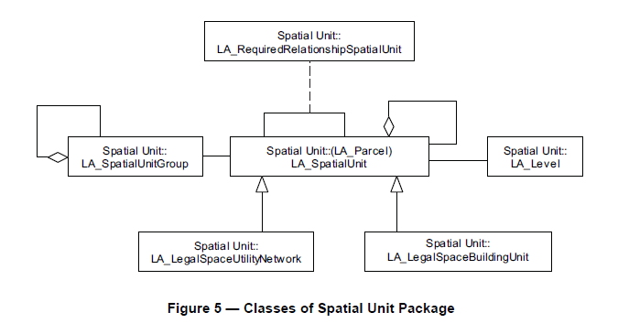
An instance of LA_Level is a level.
Required relationships are explicit spatial relationships between spatial units, and instances of class LA_RequiredRelationshipSpatialUnit. Sometimes there is a need for these explicit spatial relationships, when the geometry of the spatial units is not accurate enough to give reliable results, when applying geospatial overlaying techniques (e.g. a building, in reality inside a parcel, is reported to fall outside the parcel; the same applies to the geometry of a right, e.g. an easement). Required relationships override implicit relationships, established through geospatial overlaying techniques.

Proposed LandInfra adoption of 5.5 Spatial Unit Package
LA_SpatialUnit, or better LA_Parcel, is the basic spatial unit. LA_BAUnit consists of one or more LA_Parcel. The definition 4.1.23 reads that ' spatial unit [is a] single area (or multiple areas) of land (4.1.9) and/or water, or a single volume (or multiple volumes) of space. NOTE 1 [adds that] A single area is the norm and multiple areas are the exception. In the draft, the corresponding class is ParcelUnit, but LandParcel may be a better term. CaLAThe and CIPV have CadastralParcel.
LA_SpatialUnitGroup refers to administrative districts. These could be provided for through attributes and/or enumerations, and related to parcels and boundaries. This provided, explicit reference to LA_SpatialUnitGroup seems not needed for the purpose of Surveying and LandParcel within LandInfra .
LA_Level allows for various levels of recording, cf. the standards' remarks concerning LA_RegisterType and the two basic categories of properties of a feature (OGC Abstract Spec Topic 20, 7.1.1). Application of Topic 20 should do.
The two specializations of LA_Parcel: LA_LegalSpaceBuildingUnit and LA_LegalSpaceUtilityNetwork, are both needed in the LandInfra, already because LandXML includes Parcel+buildingLevelNo and Parcel+BuildingNo and thus testifies the need that LandInfra covers the measuring of condominium units / strata title. Whether condominiums and utility networks should be defined as specializations of LA_Parcel seems not convincing. The structuring provided by CityGML and/ or IFC should be given priority.

5.6 Surveying and Representation Subpackage
The four classes of the Surveying and Representation Subpackage are (1) LA_Point, (2) LA_SpatialSource, (3) LA_BoundaryFaceString, and (4) LA_BoundaryFace, see Figure 6.
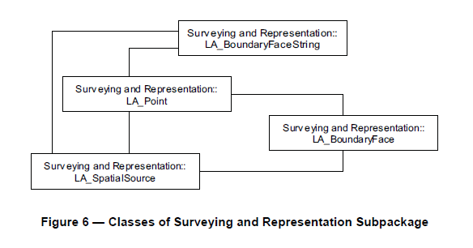
Points, as instances of LA_Point, lines and surfaces can be acquired in the field (with classical surveys, or with GNSS), in an office, or compiled from various sources, for example using forms, field sketches, ortho-images or orthophotos. The acquisition of points, lines or surfaces (a survey) may concern the identification of spatial units on a photograph, on an image, or on a topographic map; cycloramas or pictometry methods (multiple images from different angles) may also be used for that purpose.
A survey is documented with spatial sources, instances from class LA_SpatialSource. This may be the final (sometimes formal) documents, or all documents related to a survey. Sometimes, several documents are the result of a single survey. A spatial source may be official, or not (i.e. a registered survey plan, or an aerial photograph). Paper based documents (which may be scanned) can be considered as an integral part of the land administration system.
The individual points are instances of class LA_Point, which is associated to LA_SpatialSource. While it is not required that the complete spatial unit is represented, a spatial source may be associated to several points. Geodetic control points, including multiple sets of coordinates for points, and with multiple reference systems, are all supported in the LADM.
2D and 3D representations of spatial units use boundary face strings as instances of class LA_BoundaryFaceString, and boundary faces as instances of class LA_BoundaryFace.
Coordinates themselves either come from points, or are captured as linear geometry.
The LADM supports the increasing use of 3D representations of spatial units, without putting an additional burden on the existing 2D representations. Another feature of the spatial representation within the LADM is that there is no mismatch between spatial units that are represented in 2D and spatial units that are represented in 3D. See Annex B for more details. The LADM is based on accepted and available spatial schemata, such as that published in ISO 19107:2003.
The latter point is explained in Oosterom et al. (2013) as follows: A boundary is a set of points that represents the limit of an entity (ISO 19107:2003, definition 4.4). A boundary face string is a boundary forming part of the outside of a spatial unit. Boundary face strings are used to represent the boundaries of spatial units via line strings in 2D. .. Boundary faces are used when the implied vertical and unbounded faces of a boundary face string are not sufficient to describe 3D spatial units. Boundary faces close volumes in height (e.g. every apartment floor), or in depth (e.g. an underground parking garage), or in all other directions to form a bounded volume.

Proposed LandInfra adoption of 5.6 Surveying and Representation Subpackage
LA_Point, LA_BoundaryFaceString, and LA_BoundaryFace are all needed for LandInfra. The BoundingElement of the draft provides a focus on the essential.
As for LA_SpatialSource, see the remarks above regarding section 5.4.

4. Comparisons
The selected classes and attributes from the LandXML packages Parcels and Survey are listed below, here not in alphabetical order, but in sub-domains according to mutual relationship, intuitively drawing on the Cadastre and Land Administration Thesaurus (CaLAThe). Next, the corresponding LADM classes are added, and finally classes from the published Draft LandInfra Conceptual Model.
Sub-domain | LandXML | LADM | LandInfra
1. Parcel | Parcels  Parcel  Parcel+parcelType | LA_BAUnit  LA_Parcel  LA_LegalSpaceBuildingUnit LA_LegalSpaceUtilityNetwork | LandParcel  ParcelUnit  ?? Building does not fit  Facility
 | CoordinateGeometry::CoordGeom | LA_Point  LA_BoundaryFaceString  LA_BoundaryFace | Point  BoundingElement  BoundingElement
 | CoordinateGeometry::Center  Parcel+area  Parcel+volume | LA_Parcel+referencePoint  LA_Parcel+area  LA_Parcel+volume | Bound.gElement+point  ParcelUnit+area  ParcelUnit+volume
2. Naming / identifying spatial  objects | Parcel+buildingLevelNo  Parcel+buildingNo  Parcel+name  Parcel+refer.ces(LocationAddress)  Parcel+references (Title)  Parcel+taxid | ~ LA_Parcel+extAddressID  LA_LegalSpaceBuildingUnit+extPhys.Build.UnitID  LA_Parcel+suID  LA_Parcel+extAddressID | Missing!  Missing!  LandParcel+parcelID  Missing!

3. Document | Core::FieldNote  SurveyHeader | LA_Party (Survey and FieldNote author)  LA_AdministrativeSource  LA_SpatialSource | Missing!  LandInfra(core)  Missing!
4. Legal / administrati. aspects | Parcel+liabilityApportionment  Parcel+lotEntitlements  Parcel+owner  Parcel+setbackF..R..S  Parcel+state  Parcel+useOfParcel | ?  LA_PartyMember+share  LA_Party (as owner)  LA_Restriction (~easement)  LA_Restriction (~easement) | ? needed  ? needed  LandParcel+owner  Missing!  LandInfra::Status  Missing!
5. Features of terrain objects and project elements | Core::Feature  SurveyMonument | LA_Point+monumentation | Missing!  Missing!

5. Summary
- Buildings and building components are so far not addressed (cf. LA_LegalSpaceBuildingUnit; Parcel+buildingLevelNo; Parcel+buildingNo;). Cadastral survey activities include the measuring and documenting of components of condominiums. The modelling applied for the Core Immovable Property Vocabulary is added for inspiration, Figure X:
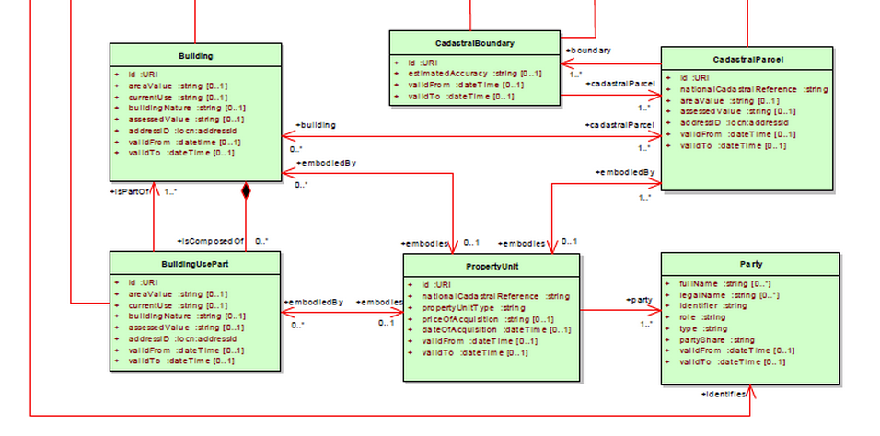
Figure X: UML Class diagram of Core Immovable Property Vocabulary.
Extract, disregarding related, existing classes. Source: Cagdas, 2014
- The naming / identifying of spatial objects is hardly addressed. Such specializations of an abstract PlaceName may be considered outside the scope of LandInfra, but should be addressed because of their role in practice, especially the post address. A status on international post address standards is provided by Coetzee, 2008 and Coetzee, Bishop, 2009
- The LandInfra draft hardly reflects the different document types of a Project. Even if data are assumed to be stored in a database and recombined, the recording of responsible person calls for a 'segmentation' of data in one way or another. This 'segmentation' should probably take place according to rules specified by the standard. - In Danish practice, land development is documented by three types of documents: Maps, describing the spatial relations of Parcel, etc.; TabularSheets, accounting for the content and change of Parcels, etc, and the numerical and legal implications; and Statements of owners, other right holders, and authorities, who request or approve the said changes. LandXML Core::FieldNote, and LA_SpatialSource may be considered specializations of Maps. Maps and the TabularSheets are signed by the licensed surveyor, the other documents by the respective parties.
- Comments on legal / administrative aspects are deferred here.
- Terrain features (edge of house, ditches, ..), cf. the draft's Site, and SurveyMonument need be at least enumerated by the standard. An example: A heritage area is protected by an easement. It is totally located within the legal boundaries of a Parcel. The easement boundaries need be measured/ recorded for the right of way process. How can this be covered by the LandInfra?

Erik Stubkjær, est@land.aau.dk – 2015-05-26; -05-06; 04-25

